Nene Diallo, David Devkota, Osamwonyi.I

Python for Business Analytics: SQL Check-up

3/29/22

Given the two data tables below, please provide SQL queries for the following questions. If needed, you can segment your answer into more than one query.

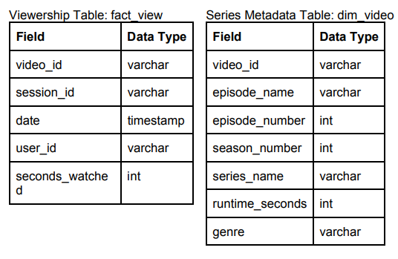

**SQL Project**

**Question 1 : How many unique viewers did the Game of Thrones & Westworld garner in the past 7 days? [ hint: use series_names]**

Query1:

select count(distinct VW.user_id) as UniqueViewers

from fact_view VW JOIN dim_video V ON (VW.video_id=V.video_id)

where V.series_name IN ('Game of Thrones','Westworld gamer')

and VW.date between DATE(NOW() - INTERVAL 7 DAY) AND DATE(NOW());

**Question2: What is the average completion rate ( seconds watched divided by runtime) for the first episode of every series?**

**Query 2**

select V.series_name, ROUND(SUM(VW.seconds_watched) / MAX(V.runtime_seconds),2) as AvgCompletionRate

from fact_view VW JOIN dim_video V ON (VW.video_id=V.video_id)

where V.episode_number=1

Group by V.series_name;

Extra Credit:

**Question 3: What is the 2nd most watched episode per genre in terms of minutes watched?**

Query 3

Select genre, episode_number, MinutesWatched, RANK() OVER ( ORDER BY MinutesWatched ) as Rank

from

(

select V.genre as genre, V.episode_number as episode_number,

(SUM(VW.seconds_watched)/60) as

MinutesWatched

from fact_view VW JOIN dim_video V ON (VW.video_id=V.video_id)

Group by V.genre, V.episode_number

) A

Where Rank=2;